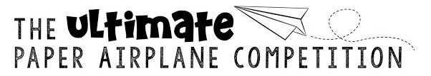
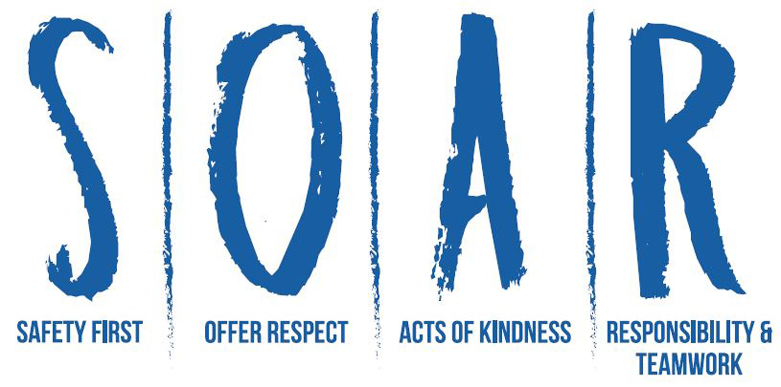
Elbridge Elementary/JEDIS Paper Airplane Contest

Introduction
These instructions will guide your students in making paper airplanes and competing in two categories: distance traveled and time spent flying in the air. Students can participate in this activity individually at school or home, in teams, or as a class.
Students can build two different types of paper airplanes. One paper airplane should be designed to fly as far as possible. The other paper airplane should be designed to stay in the air as long as possible. Students can compete in one or both events.
Before building their paper airplanes, students should research the basics of aerodynamics and flight.
Note: Cardboard planes and planes made from paper airplane kits should not be used. Make sure you make this clear to students and then check the materials in students' planes to make sure they are made out of only the allowed materials listed below.

Building the Paper Airplanes
Step 1: Encourage students to research aerodynamics before they begin designing their own planes. Print out copies of "What Makes Paper Airplanes Fly?" for students to read or provide your own research materials. Share this competition with parents.
Step 2: Hand out four 8.5" x 11" sheets of copy paper to each competitor or team. Students must use the paper given to them, though they may choose to use one or two sheets per paper airplane. Students can work on this at home.
Step 3: Students may use the following optional materials for each competitor or team. Explain to students that the following materials are not required, but may be used if the students desire.
- Up to 3 paper clips (large or small; metal or color)
- Up to 10 centimeters of tape
- A dab of glue and/or five or fewer staples
- A single other item (it can be anything other than something sharp)
Step 4: Allow students to work on their paper airplanes through March 8th, 2019. All competitors should have the same amount of time to complete their airplanes. Students should record information about their planes in a data notebook. Items to measure can include: style of plane, number of paperclips used, distance flown, time aloft, etc.

Planning the Competition
Design, build, and test phase: February 15 to March 8
Classroom competition: Between March 11 to March 15
Finalists compete: March 22 (SOAR assembly)

Classroom competition

Invite your students to research, construct, and test fly during classroom free time, STEM, and/or at home between February 15 to March 8. During the week of March 11, hold a classroom competition among your students to select a finalist. Finalists can continue testing/modifying their planes between March 15 to March 21. Finalists will fly their final airplanes at the March 22nd SOAR assembly. Winners are chosen by grade level in both the distance and time categories (4YP through 3rd grade & JEDIS).

Distance Test Rules
For the distance category, each student must throw his or her paper airplane while he/she or a teammate records distances in meters and centimeters. All distances must be measured from a starting line to the straight-line point where the plane finally lands. Each student has up to three chances to get his or her best distance.

Time in Air Test Rules
For the time-in-air category, each student must throw his or her airplane while you time the flights with an accurate stopwatch. Report the times in seconds and hundredths of a second. (Example: 2.45 seconds.) Each student has up to three chances to get his or her longest "time in air."
Happy flying!

