**Jordan-Elbridge Central School District Budget Report & Goals: 2025-26**

Mr. R. J. Hartwell, Assistant Superintendent, JECSD

February 5, 2025

**Introduction**

The Jordan-Elbridge Central School District faces significant challenges in the upcoming 2025-26 school year, primarily due to an anticipated minimum increase in New York State aid for the school district. As per Governor Hochul's executive budget, rural schools like Jordan-Elbridge are targeted for the minimum aid increase of 2%, necessitating a strategic and prudent financial approach to maintain the district's mission, vision, and values.

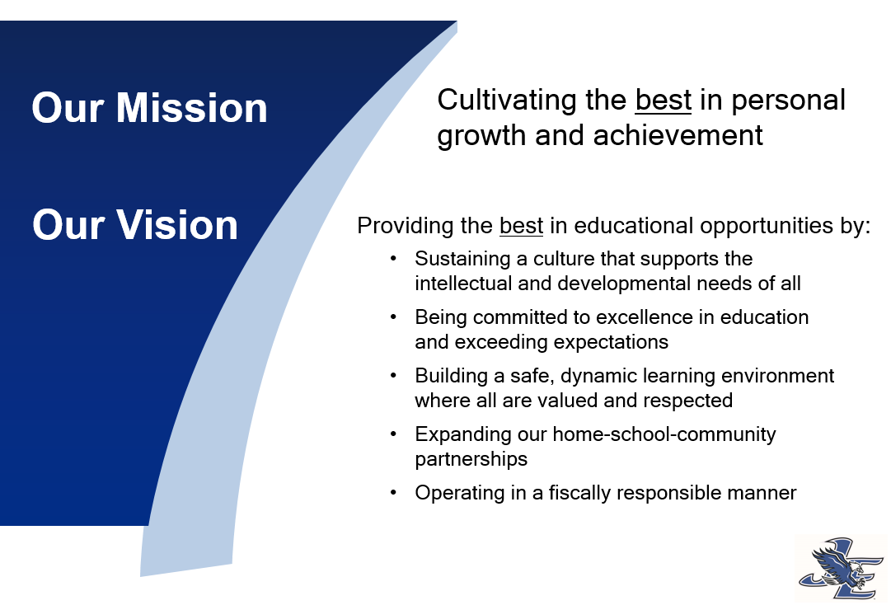

*Figure 1: The Jordan-Elbridge CSD’s mission and vision*

The budget for the 2024-25 school year is $37,415,000. The local tax levy was $13,200,000, a 0% increase from the 23-24 school year. The Community Tax Levy (CTL) is 35% of the total school budget. The remaining 65% comes from other local, state, and federal sources, as well as an appropriation of $3,000,000 from the district’s reserves.

**Current Economic Trends**

The Jordan-Elbridge Central School District, like many public school systems, is influenced by various economic trends and policy decisions at both the state and federal levels. As the 2025-2026 school year approaches, several key factors are anticipated to impact the district's finances:

**1. State Funding Adjustments:**

* **Foundation Aid Increase:** New York State has proposed an increase in Foundation Aid, which is the primary source of state funding for public schools. For the 2025-2026 school year, the Board of Regents has requested an additional $1.668 billion in Foundation Aid, bringing the total to approximately $26.6 billion statewide. This increase aims to promote equity across districts. However, the JECSD is currently slated to receive the minimum 2% aid increase, which is equivalent to approximately $234,000 (this corresponds to a CTL of ~1.8%).
* **Potential Changes to Funding Formulas:** Discussions are underway to update New York's school funding formulas, which have remained unchanged for 17 years. These changes could affect how funds are allocated to districts, potentially impacting the Jordan-Elbridge Central School District's revenue beyond the 2025-26 school year. It is believed a revised formula will benefit rural schools across the state.

**2. Federal Initiatives and Associated Costs:**

President Donald Trump's proposals to significantly reduce or eliminate the U.S. Department of Education (DOE) could have notable implications for public schools in New York. The Jordan-Elbridge Central School District would not be immune.

The DOE administers critical funding programs such as Title I, which supports schools with high numbers of low-income students, and other grants for special education services. In the 2024–25 school year, over 1,000 local education agencies in New York State received more than $1.3 billion in Title I funding. Eliminating the DOE could jeopardize these funds, potentially leading to budget shortfalls for districts like Jordan-Elbridge. In 2024-25, Title I funding totaled $265,990 for our district (equivalent to ~2.0% CTL).

**3. Rising Operational Expenses:**

* **Healthcare and Employee Benefits**: The increasing costs of healthcare and employee benefits continue to strain school district budgets. The Cayuga Onondaga Area School Employees Healthcare Plan (COASEHP) is anticipating a possible increase to its healthcare premiums of 8-10% for all component schools, including JECSD (with the district share seeing a potential ~$400,000 increase).
* **Inflation and Supply Chain Challenges:**  Ongoing inflation and supply chain disruptions are continuing to result in higher costs for goods and services essential to school operations, from classroom supplies to transportation.
* **State Mandates / State Law**: New York State’s law to require the purchase of non-diesel (i.e. electric powered) school buses becomes effective January 1, 2027. Thus, the 2025-26 school year may be the last year in which the district can purchase traditional diesel- and gasoline- powered buses (currently ~$150,000 each). Electric school buses are estimated to cost ~$450,000 each. If the district maintains its bus replacement schedule (replacement of 3 large buses and 1 mini bus), the total cost will be approximately $650,000 in the 25-26 school year. In the following years, the same replacement (at today’s costs) would be $1,650,000, representing a $1 million increase each year (equivalent to ~7.2% CTL per year starting in 2026-27).

**4. Enrollment Fluctuations:**

* **Demographic Shifts:**  Changes in student enrollment numbers can significantly impact funding, as many state aid formulas are enrollment-based. A decline in students, as observed in many New York districts, could lead to reduced funding, necessitating budget adjustments. The enrollment at JECSD is slowly trending down, from 1,230 in 2021 to 1,144 in 2025. An estimated enrollment for the 25-26 school year is 1,136 (almost 1 % per year). This trend is similar (albeit slower) to other schools in our area.

In summary, the Jordan-Elbridge Central School District should prepare for a dynamic financial landscape in the 2025-2026 school year, shaped by funding changes, state initiatives (i.e. school bus electrification), rising operational costs, state aid regularly below the annual inflation rate, and negative enrollment trends. Proactive engagement with policymakers and careful budget planning will be essential to navigate these challenges effectively.

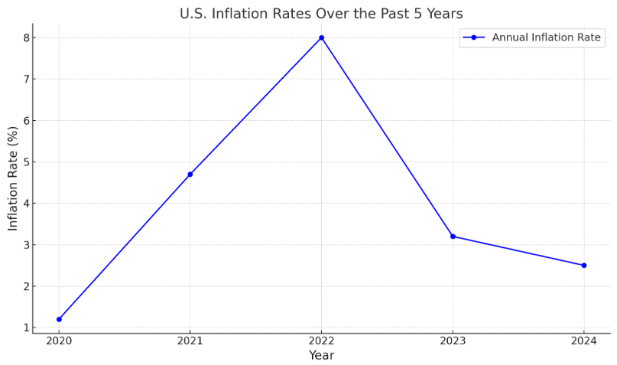

*Figure 2 (above): Inflation rate – 5 year look back (currently 2.9% in January ’25)*

**Aligning Budget Goals with Mission, Vision, and Values**

The budget goals outlined for the 2025-26 school year reflect the district's commitment to academic excellence, character education, and fiscal responsibility. By adhering to these goals and leveraging available resources efficiently, the Jordan-Elbridge Central School District can continue to provide high-quality education while minimizing the local tax impact.

### Sustain High-Quality Instruction and Learning Opportunities

Prioritize funding for core academic programs and essential resources to maintain high standards of teaching and learning, even with limited state aid increases.

* + Focus on maintaining teacher-student ratios to support personalized instruction.
  + Invest in professional development to equip staff with innovative teaching strategies.
  + Protect funding for critical curriculum areas, including STEM and the arts.

### Enhance Student Wellness and Support Services

Allocate focus on strengthening mental health, counseling, and special education services to ensure all students feel supported socially and emotionally.

* + Promote equity by ensuring all students have access to necessary resources, regardless of socioeconomic status.

### 

### Foster Fiscal Responsibility and Operational Efficiency

Implement cost-saving measures and operational efficiencies to maximize the district's limited resources without compromising the quality of education.

* + Explore shared service agreements with nearby districts to reduce expenses.
  + Prioritize investments with the highest long-term impact, deferring non-essential projects.

**Impact on the Jordan-Elbridge Central School District**

The planned minimum increase of 2% in New York State aid for the Jordan-Elbridge Central School District results in yet another year of financial strain. Despite the district's commitment to preserving all student programming, achieving academic excellence, maintaining safe environments where all are valued and respected, and operating in a fiscally responsible manner, meeting these goals requires careful financial management and innovative strategies to achieve.

The figure on the next page details the state aid breakdown for the JECSD estimated from the Governor’s executive budget proposal published on January 21, 2025:

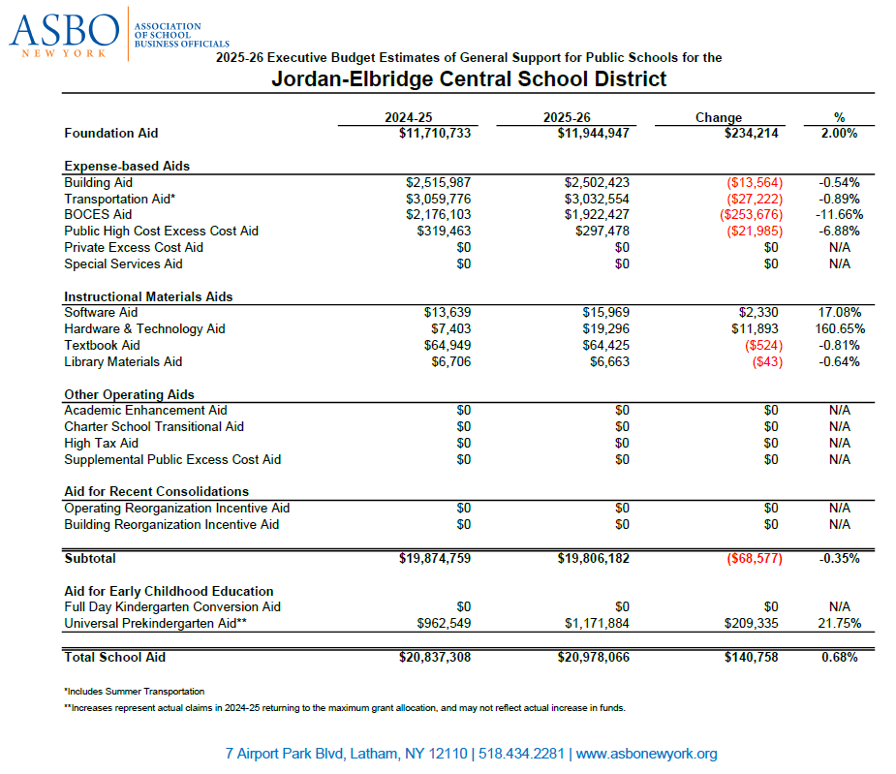

*Figure 3 (above): Gov. Hochul’s 25-26 state aid proposal for JECSD (presented by ASBO)*

**Conclusion**

In navigating the financial challenges posed by insufficient state aid below current inflation values, rising contractual costs, and potential costly state mandates, the Jordan-Elbridge Central School District remains steadfast in its commitment to serving students, families, and the community. Through prudent financial management, strategic planning, and an unwavering focus on its mission, vision, and values, the district will overcome these obstacles and continue to thrive in the 2025-26 school year and beyond.